**Project 2 Report**

**Team 45**

Kathryn Atherton

Joshua Hahn

Hannah Mackin Schenck

610 Purdue Mall

West Lafayette, IN 47906

(123) 555-4567

ceo@starpowerinc.com

April 1, 2016

Dr. Seymour Glass, CEO

Solar Crystals Inc.

3035 Coronado Drive

Santa Clara, CA 95054

Dear Dr. Glass,

Our company was tasked with modeling a system which stores solar energy in the form of potential energy. This is accomplished by using incoming solar energy to pump water uphill into a reservoir. The reservoir is then emptied over a period of time, converting the potential energy into usable electrical energy. The company conducted extensive research into the various factors, including efficiency, cost, filling and emptying times, building materials, and available building locations. A computer program was created to model such a system, which considered the above factors in order to maximize the efficiency of the energy storage facility and minimize costs.

Our recommendation is to construct on Zone 3. For materials, we recommend using the Premium Pump with a flow rate of 25 m3/s, the Best Turbine with a flow rate of 15 m3/s, 162 m of Glorious pipes with a diameter of 1.5 m, two 20o fittings, and two 45o fittings. Finally, we recommend building a circular reservoir with a diameter of 209.58 m and a depth of 20 m. This total system costs $585,938 and has an efficiency of 70%.

Sincerely,

Jane Smith, CEO of Star Power Inc.

**Executive Summary**

The team began research for the project by investigating various factors that would ultimately affect the design. These factors included efficiency of the pump and turbine, the friction due to the pipes, the energy losses due to bends in the pipes, the pump and turbine flow rates, and loss of mass due to evaporation.

The model takes into consideration the length and type of pipe used, the number and type of bends in the pipes, the volumetric flow rate and efficiency of the turbine and pump, and the elevation and depth of the upper reservoir. Given these inputs, the model generates the mass of water to be stored, the required surface area of the reservoir, the time needed to fill and empty the reservoir, required energy input to pump the water to the reservoir, and the total efficiency of the plant.

The model operates on the assumptions that the reservoir is completely filled when the required output energy equals 120 MWh, that pipe areas and water velocities are constant, that turbine and pipe volumetric flow rates are constant, and that the pipes are full of water at all times.

There are a few limitations with the model. Primarily, the model does not take into account any other effects on the system besides those mentioned above. Other effects that might play a role in the operation of the plant include evaporation of water in the reservoir, rainfall, and turbulence. However, the team decided that these effects were insignificant and hence were not included in the model.

Using the model, the team determined the optimal system design for each zone. The team assumed that the cost to efficiency ratio was the most important factor. The team also assumed that any environmental impacts could be mitigated by setting aside the recommended budget. With this in consideration, the team recommends that Solar Crystals Inc. use Zone 3 and purchase the Premium Pump with a flow rate of 25 m3/s, the Best Turbine with a flow rate of 15 m3/s, 162 m of Glorious pipes with a diameter of 1.5 m, and two 20o fittings and two 45o fittings. This total system costs $585,938 and has an efficiency of 70%.

**Cost Impact Analysis**

In constructing the model, the team investigated a variety of factors that would add or detract from the overall efficiency of the system. These factors included turbine and pump efficiencies, energy lost to friction lost in the pipes, energy lost to bends in the pipes, mass lost from the reservoir to evaporation, mass added to the reservoir from rainfall, internal changes of the water, and malfunctions in plant operations such as damaged equipment or leaks.

Head loss to pipe friction is governed by the Darcy-Weisbach equation. After a sample calculation, it appears that this factor will be significant.

Equation 1: Darcy-Weisbach Equation

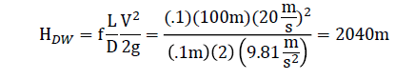

Evaporation of a large surface is governed by the following equation.

Equation 2: Evaporation from Water Surfaces

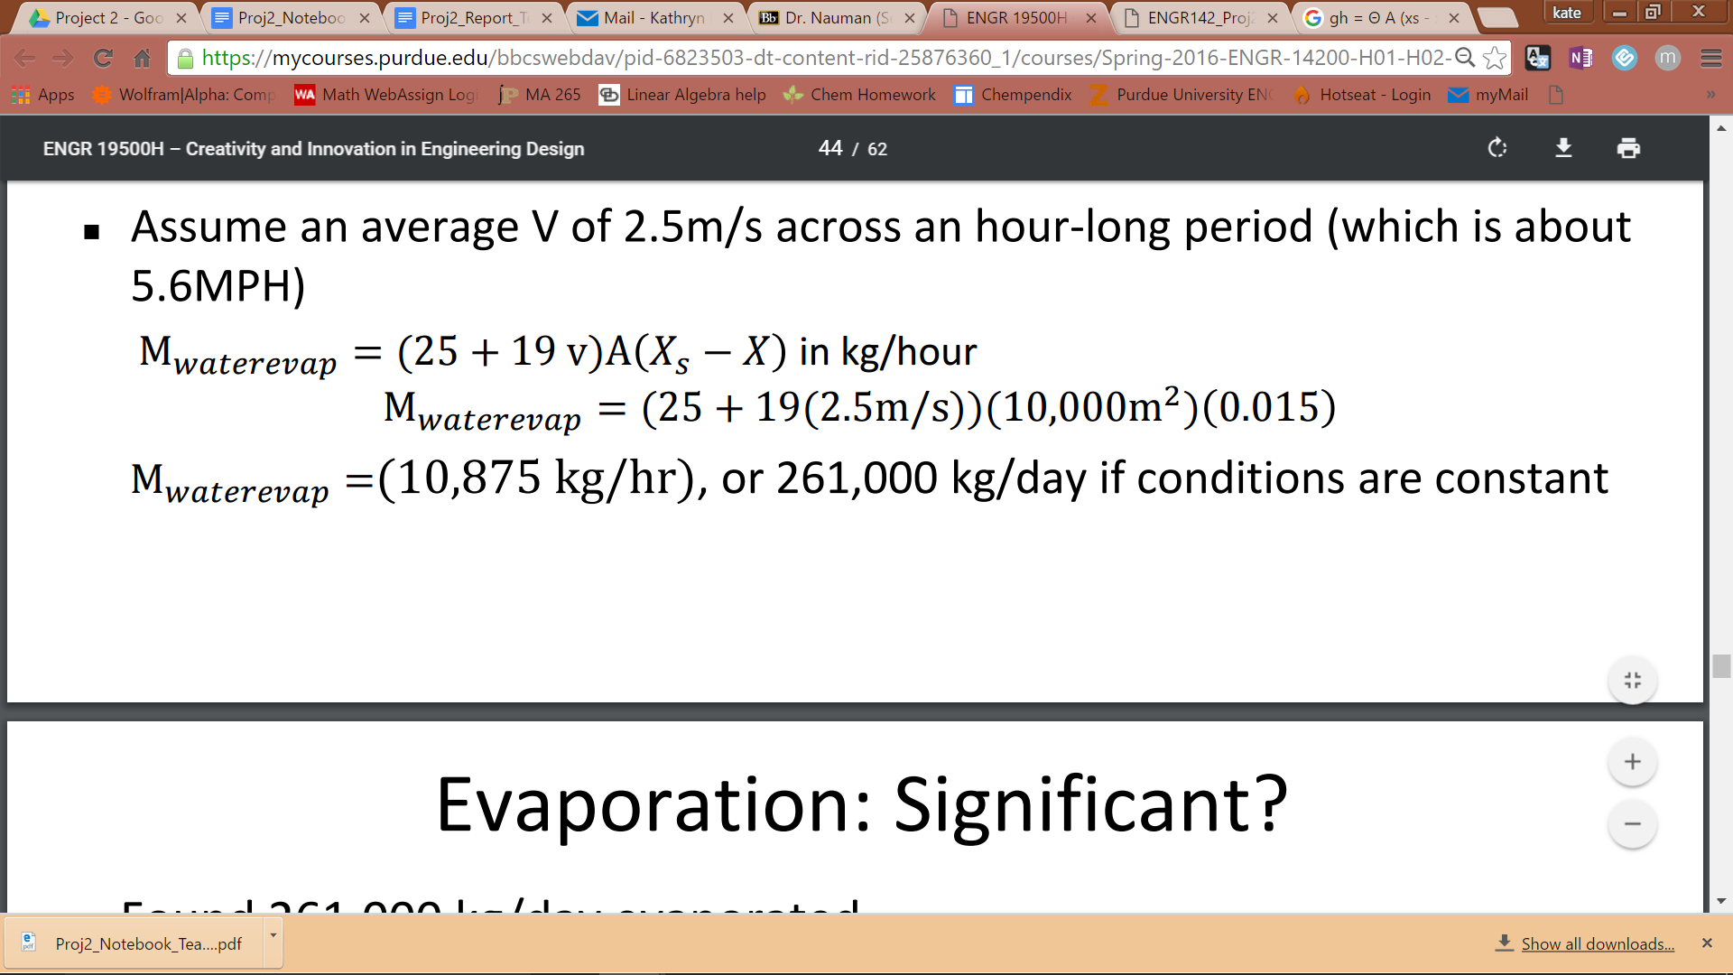

However, even with completely dry air and large wind speeds, evaporation would only result in a .26% loss per day, which the engineering team decided was insignificant.

Next the team considered losses due to bends in the pipes.

Equation 3: Minor Head Loss in Pipes and Tube Systems

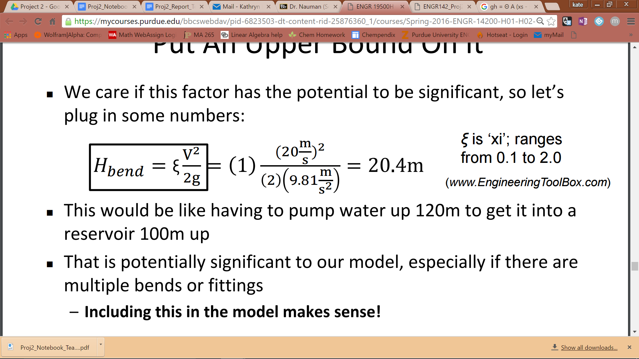

With a bend coefficient of 1 and a velocity of 20 m/s, there would be a head loss of 20.4 meters. This seems to be significant, so the team decided to include it in the model.

Rainfall was another factor considered. However, this factor was considered negligible because even in Hawaii, the wettest US state, rainfall would only account for .04% of the reservoir volume per day.

Finally, the team assumed that any changes in the internal state of the water due to turbulence or weather are negligible and that any issues with the plant, such as leaks, would be resolved quickly and not significantly alter plant operations.

After the preliminary research was conducted, the team began constructing the model. A flowchart demonstrating the logic of the program follows:

Figure 1: Program Logic Flowchart

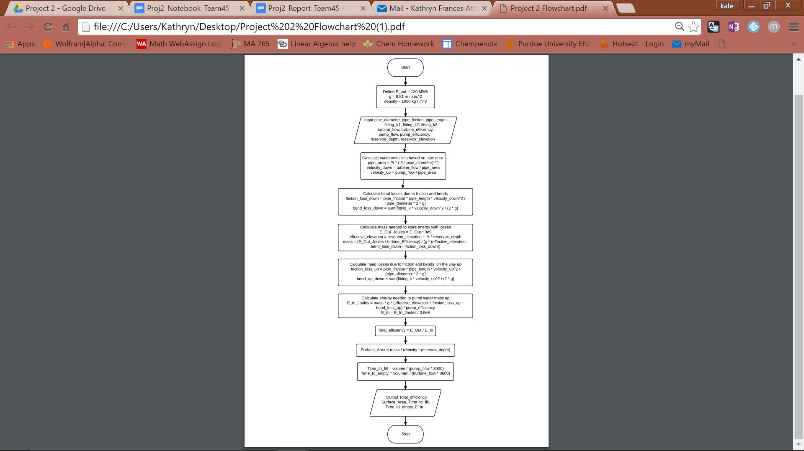

The model accepts as inputs pipe diameter (m), pipe friction factor, pipe length (m), three bend coefficients, turbine volumetric flow rate (m3/s), turbine efficiency, pump volumetric flow rate (m3/s), pump efficiency, reservoir elevation, and reservoir depth.

Given these parameters, the model calculates the flow velocity of the water using the volumetric flow rates and the cross-sectional area of the pipe. The head loss due to friction and bends is then calculated using the downward flow velocity. Given the head loss and the elevation of the reservoir, the model calculates the mass of water needed to supply 120 MWh of energy. The program then recalculates the head loss using the upward flow velocity. This is used to calculate the required input energy, and from there the total efficiency of the system.

In order to validate the model, a test case was provided to the engineering team. When ran through the program, the correct values were outputted and displayed.

Figure 2: Test Case Output Values

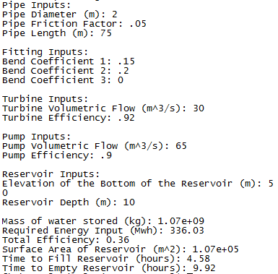

There are some assumptions and limitations to the model. The model operates on the assumption that the reservoir is completely filled when the required output energy equals 120 MWh. It is also assumed that pipe areas are constant, and therefore water velocities are constant throughout the length of the pipe. Another key assumption is that the turbine and pipe volumetric flow rates are constant. Finally, it is assumed that the pipes are full of water before and after accounting. A limitation of this model is that it only considers energy lost to pipe friction and bends. In reality, there are a variety of other factors that will affect the efficiency of the system, including evaporation, rainfall, turbulence, and maintenance issues. However, at this stage in development the effects of ignoring these factors should be negligible. Another limitation of this model is that it does not consider any extra costs of preparing the site, so these costs must be estimated outside of the model. Finally, if the sun is not out during one day, the reservoir might take longer to fill than the model predicts.

Once the model was constructed, a decision matrix was created for each site that iterated through every design choice for pump, turbine, and pipe product lines, as well as pipe diameters. The total loss and cost was calculated for each situation, and a cost-to-loss ratio was determined.

The option with the lowest ratio of cost-to-loss was found to be in Zone 1. However, the small elevation prevents the site from being practical, as high pump and turbine flow rates created more energy losses than the system could overcome and lower flow rates were not practical. Zone 2 was rejected due to social factors concerning the Native American burial ground, so Zone 3 would be the next best choice.

The team re-analyzed the decision matrix and found the most cost effective option in Zone 3. This option included the Premium Pump, the Best Turbine, 162 m of Glorious pipes with a diameter of 1.5 m, and two 20o fittings and two 45o fittings. Once these variables were determined, the team ran the scenario through the model to determine the optimal flow rates for the pump and turbine in order to make the model practical.

The team wanted the reservoir to fill within eight hours and empty within 16 hours, in order to have the system complete the cycle of filling and emptying in about 24 hours. After running the scenario through the model, the optimal pump flow rate was determined to be 25 m3/s, and the optimal turbine flow rate was determined to be 15 m3/s. This causes the fill time to be just under 8 hours and the empty time to be just under 13 hours. The final cost of the system comes out to $585,938, with an efficiency of 70%. The ratio of cost to efficiency of the system is $8,370.54 per percent efficiency.

**Discussion of Factors**

When making the model, external factors that would change the total energy in the system needed to be accounted for. The team brainstormed factors that would alter the amount of energy the system would be able to output. Factors that would increase the amount of output energy were rainwater and runoff water from the surrounding environment. However, the team found that there are many more factors that decrease the amount of usable energy because of the nature of the system. Some of these factors include evaporation, plant and animal consumption of water in the reservoir, friction in the pipes, mechanical inefficiencies, and bends in the pipe. It was decided that analyzing every factor affecting the system would add unneeded complexity to the model. Therefore, the team determined which factors had the greatest impact on the system. Most of the brainstormed factors had an impact of less than 1% of the total energy output by the system. It was determined that these factors would not have a discernible impact on the model, so they were discarded. The three remaining factors that had the largest impacts on the system were inefficiencies, friction in the pipes, and bends in the pipes.

When making decisions regarding the model, there were also many factors that affected the outcome. When deciding which pipes, pump, and turbine to use, the team made a decision matrix that computed the cost and efficiency of each option. Because maximizing the cost efficiency of the system was the priority, the cost per percent efficiency was compared for each option and the one with the lowest cost per percent efficiency was chosen for the final design.

Once the parts for the pumping system were selected, their efficiencies were put into the model. The team optimized the turbine volumetric flow rate and the pump volumetric flow rate using the model so that the times to fill and empty fit the required times of 8 hours and 16 hours, respectively.

In the initial evaluation of each site, the team decided that the most important factor was up front cost. Using this assumption, it was determined that Zone 1 was the best option, but after running the numbers for Zone 1 in the model, the team found that it was impossible to meet the requirements of having an efficiency above 50% and being able to fill the upper reservoir in 8 hours and empty it in 16 hours. This occurred because the head loss due to friction in the pipes was greater than the height of the reservoir. If Zone 1 had been chosen for the final site, the model could still have had a good efficiency and have been cheaper than our final solution, but the time to fill and empty would have been much longer than the team’s specifications allowed for. Therefore, Zone 1 was rejected.

Zone 2 was rejected due to social factors. It is believed that Zone 2 could have been a burial ground for the indigenous people. The team decided that destroying a sacred area is against NSPE Code of Ethics, so Zone 2 was not considered as an option for the location of the Pumped Hydro Plant.

Zone 3 turned out to be the best option for the location of the Pumped Hydro Plant because it allowed the model to have a high efficiency while also being able to empty and fill in the desired amounts of time. One factor about Zone 3 that had to be taken into consideration was erosion. There is evidence of soil erosion in the area including the uneven slope, which is believed to have been caused by the erosion over a long period of time. In this site long term erosion prevention methods may be necessary, but the team decided that benefits of Zone 3 outweighed the need for extra preventative measures.

**Conclusions and Recommendations**

After extensive research into the various factors that affected the design, the details and practicality of each of the sites, as well as the cost and efficiency of each design scenario, the team concluded that the most viable option for the construction of the Pumped Hydro Plant is in Zone 3 with the Premium Pump with a flow rate of 25 m3/s, the Best Turbine with a flow rate of 15 m3/s, 162 m of Glorious pipes with a diameter of 1.5 m, and two 20o fittings and two 45o fittings. This total system costs $585,938 and has an efficiency of 70%. Although Zone 1 had a higher cost-to-loss ratio, it was not practical due to long filling times and inefficient energy storage. The engineering team also discourages from building in Zone 2 due to ethical concerns regarding the Native American burial ground.

Although the engineering team expects this estimate to be fairly accurate, the model could be improved upon for future estimates. For example, the current model does not consider any effects on the system due to evaporation, rainfall, or turbulence. Other factors that might play a role in the system include warming and cooling effects on the water and the pipes. However, at this stage in development the model should be sufficient enough to make a decision about whether to continue with this project.

**References**

Code of Ethics. (n.d.). Retrieved April 01, 2016, from http://www.nspe.org/resources/ethics/code-ethics

Evaporation from Water Surfaces. (n.d.). Retrieved March 23, 2016, from http://www.engineeringtoolbox.com/evaporation-water-surface-d_690.html

Fairley, P. (2015, March 18). A Pumped Hydro Energy-Storage Renaissance. Retrieved March 22, 2016, from http://spectrum.ieee.org/energy/policy/a-pumped-hydro-energystorage-renaissance

Fluid Volumetric Flow Rate Equation - Engineers Edge. (n.d.). Retrieved March 31, 2016, from http://www.engineersedge.com/fluid_flow/volumeetric_flow_rate.htm

Hazen-Williams Equation - calculate Head Loss in Water Pipes. (n.d.). Retrieved March 23, 2016, from http://www.engineeringtoolbox.com/hazen-williams-water-d_797.html

Make Solar Energy Economical. (n.d.). Retrieved March 22, 2016, from http://www.engineeringchallenges.org/challenges/solar.aspx

Minor Loss Coefficients in Pipes and Tubes Components (n.d.). Retrieved March 23, 2016, from http://www.engineeringtoolbox.com/minor-loss-coefficients-pipes-d_626.html

**Appendix A**

The project schedule was set by the class lecture format (Figures 3 and 4). Research and brainstorming was conducted throughout the first week of the project, and the execution and optimization was performed the second week. The workload was distributed such that Kathryn Atherton was in charge of the documentation of the team’s process, Joshua Hahn was tasked with the creation of the code model, and Hannah Mackin Schenck was in charge of the research and calculations pertaining to the project (Figure 3).

Figure 3: Project Gantt Chart

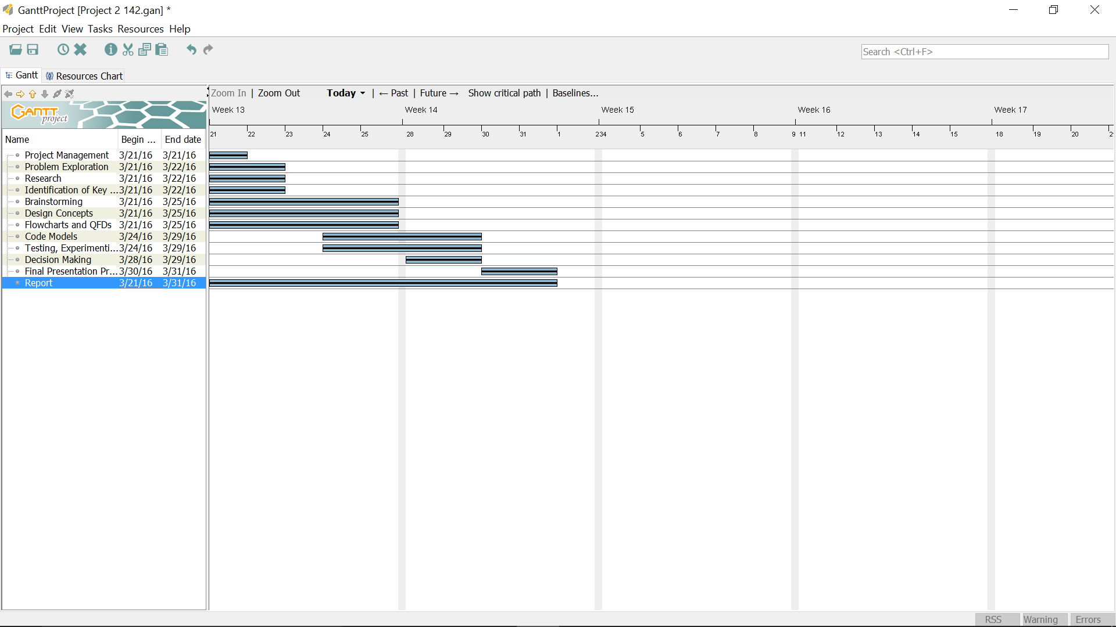

Figure 4: Work Breakdown Structure of Deliverables

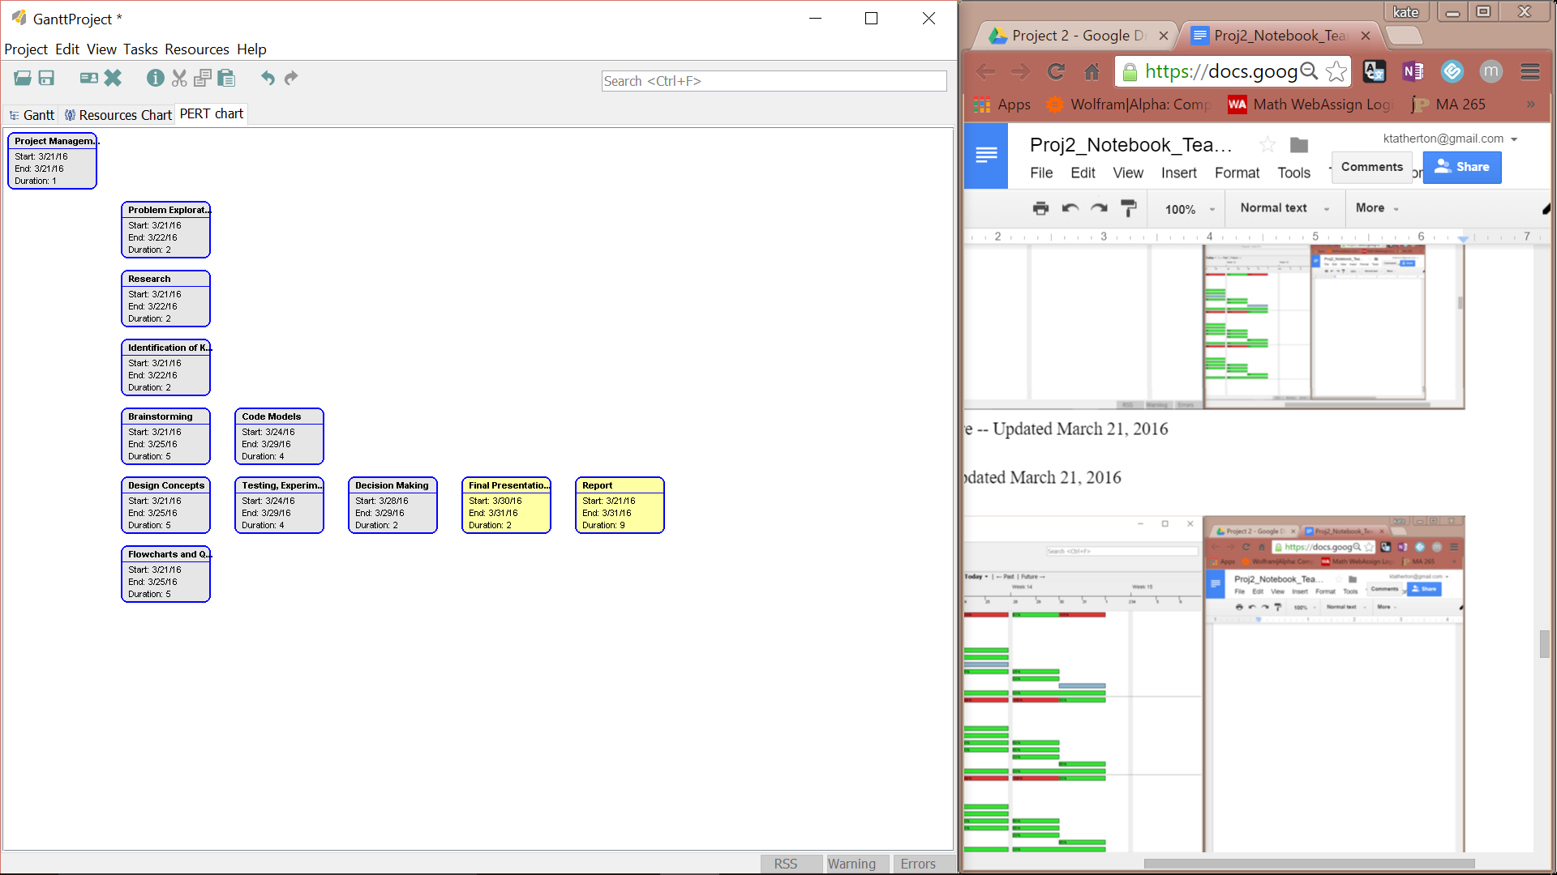

Figure 5: Workload Distribution

